CDN Task

1.Configure VPC peering in cross regions.
TITLE:
VPC-Peering

OBJECTIVE:
To establish communication between two vpcs.

PREREQUISITES:
VPC in one region
Another VPC in more region
Subnets
Route tables

STEP-BY-STEP-IMPLEMENTATION:
VPC in Stockholm region.
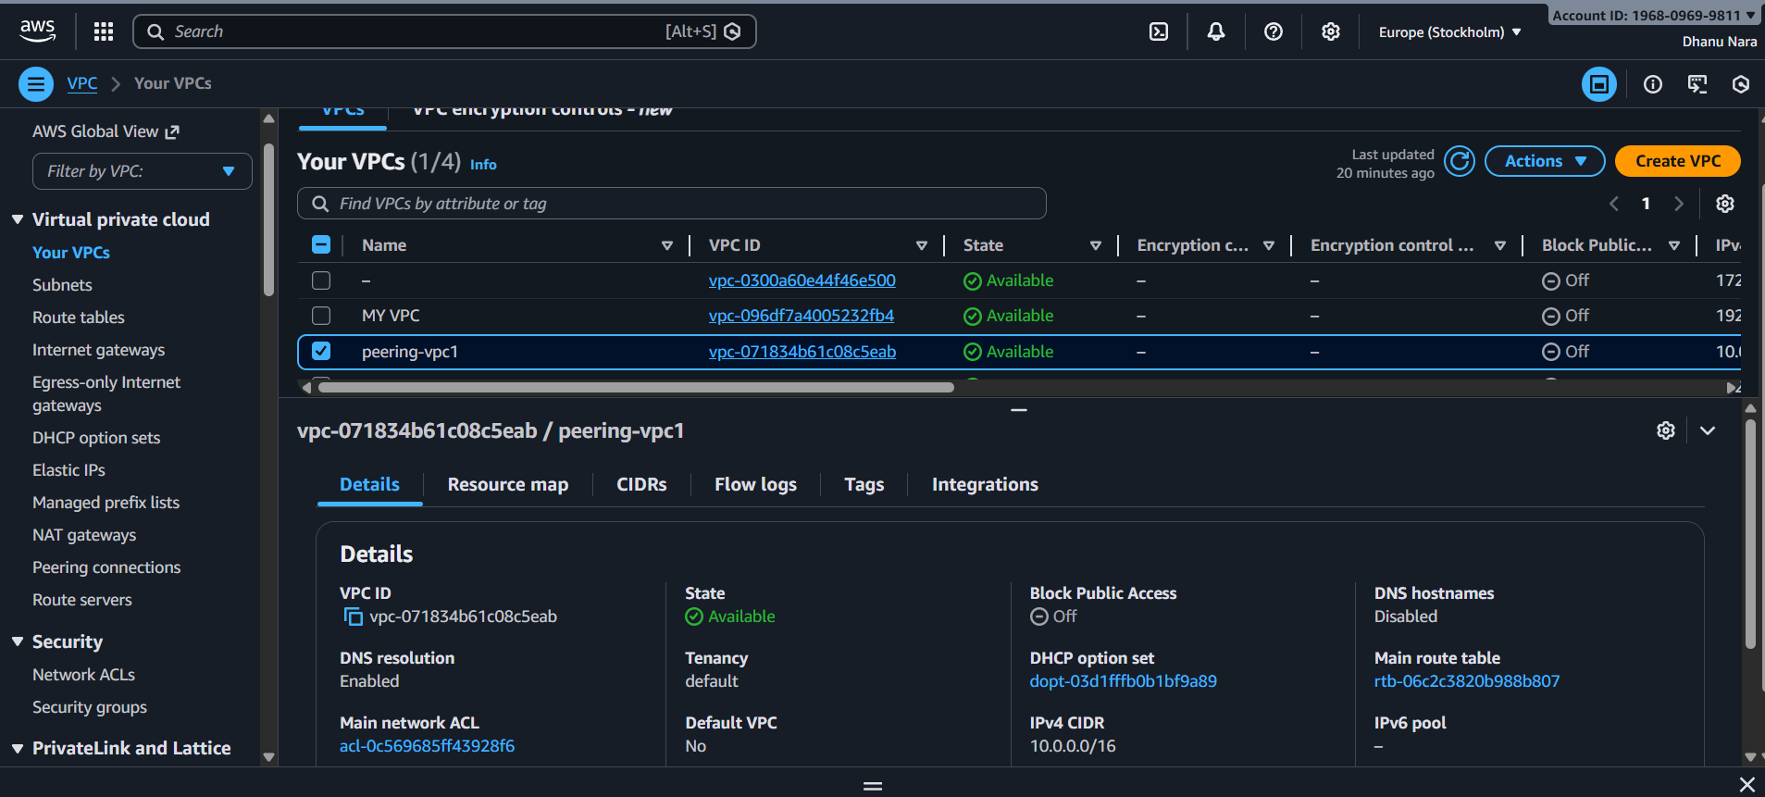

VPC in N. Virginia region
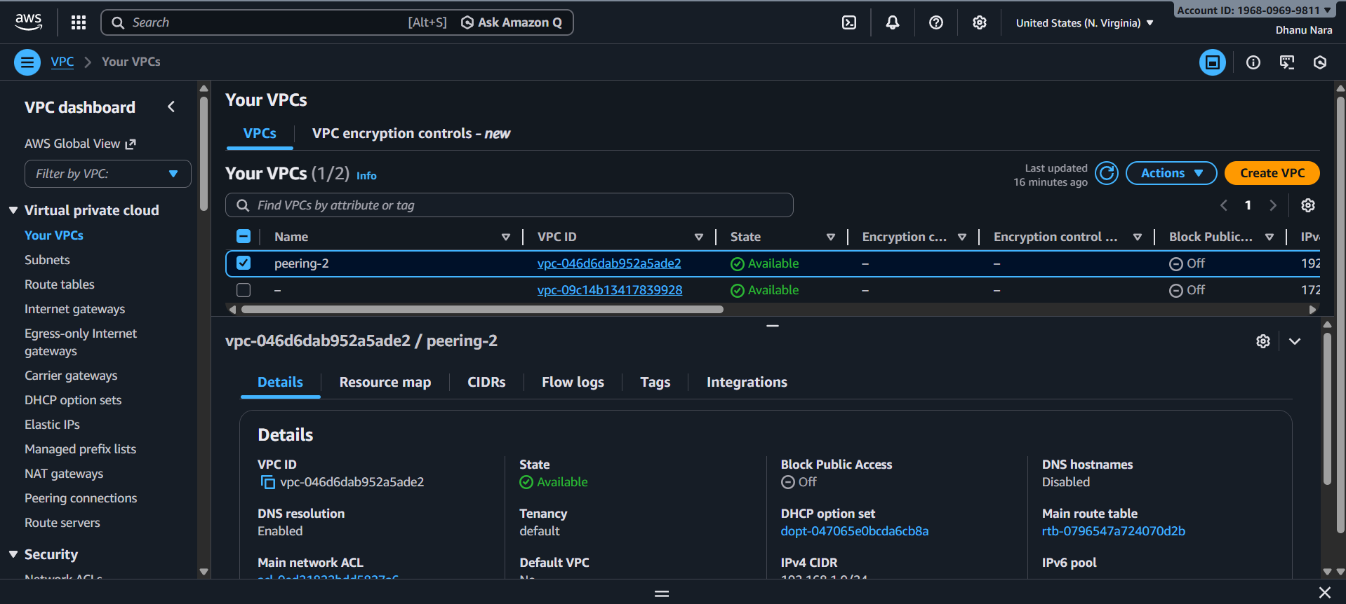
Create subnet in VPC in the CIDR range.
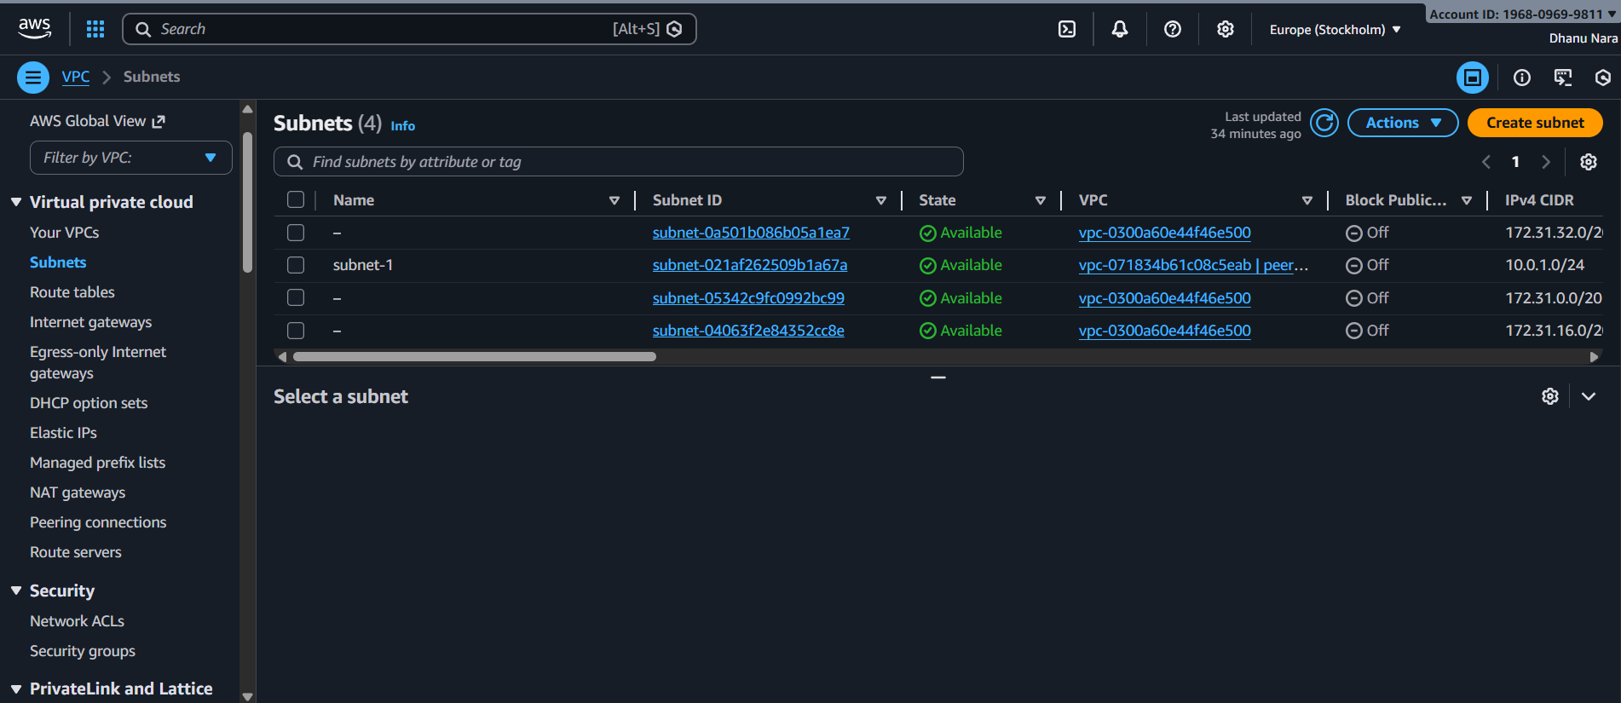
Create subnets in VPC in the CIDR range.
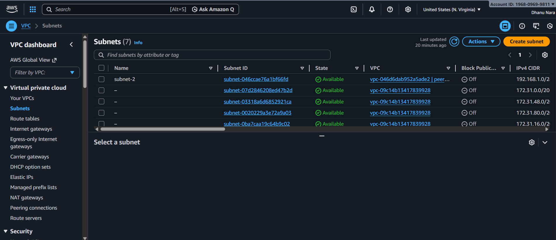
Go to peering connection in VPC and click on create peering connection and provide the details of the acceptor VPC ID. And click on save.
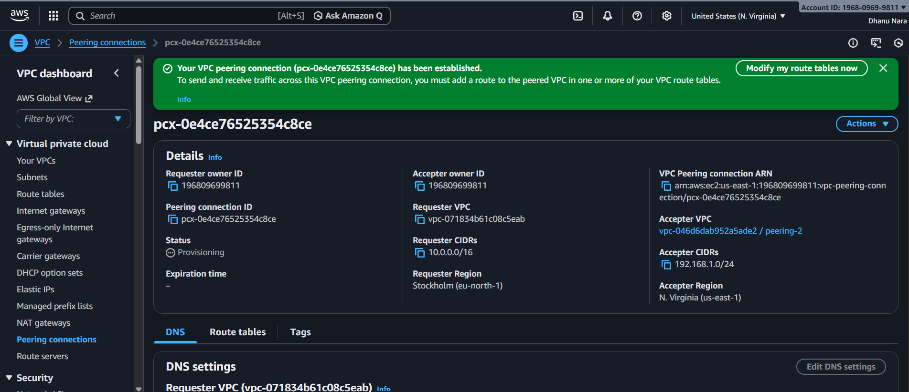
Now update the route table go to routes and add route. And there we need add the peering vpc.

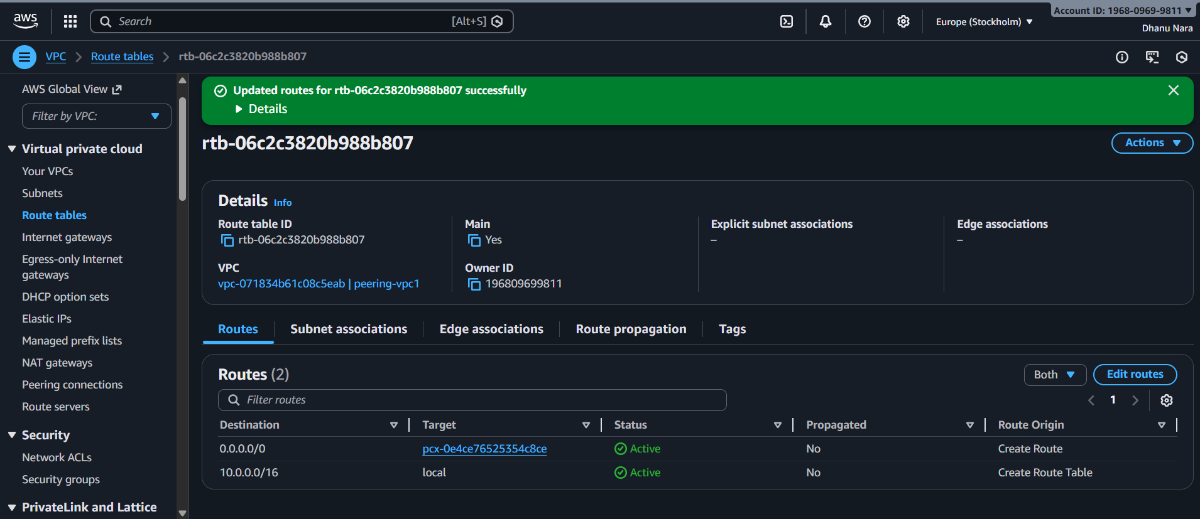
Here also update the route table.
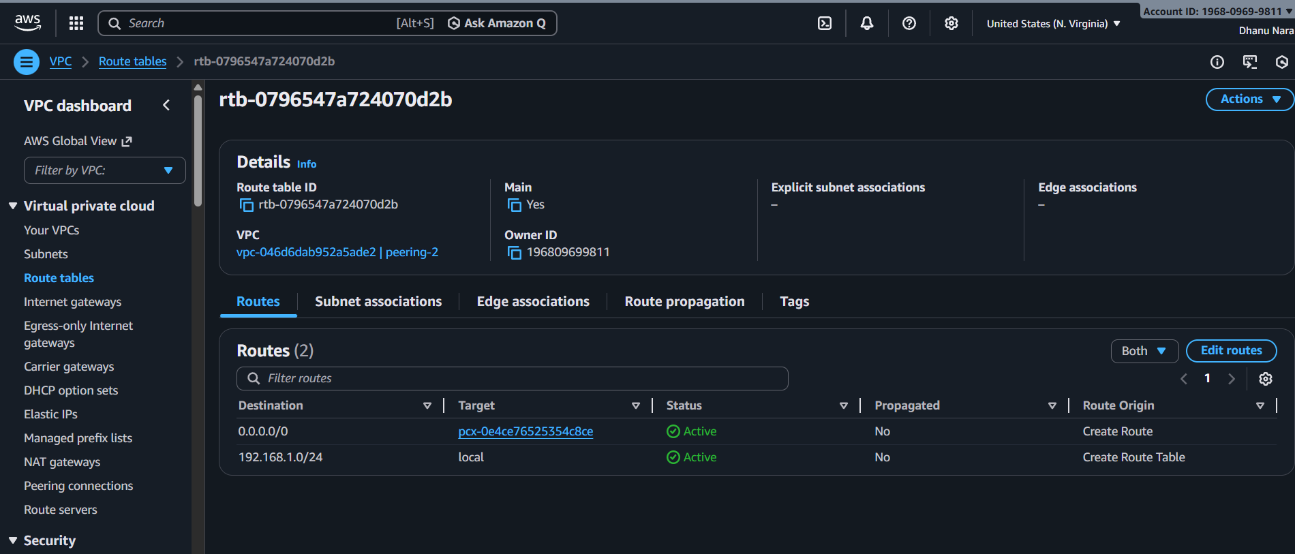
CONCLUSION:
After updating the route table the peering will get successful.

2.Purchase one domain from GoDaddy.
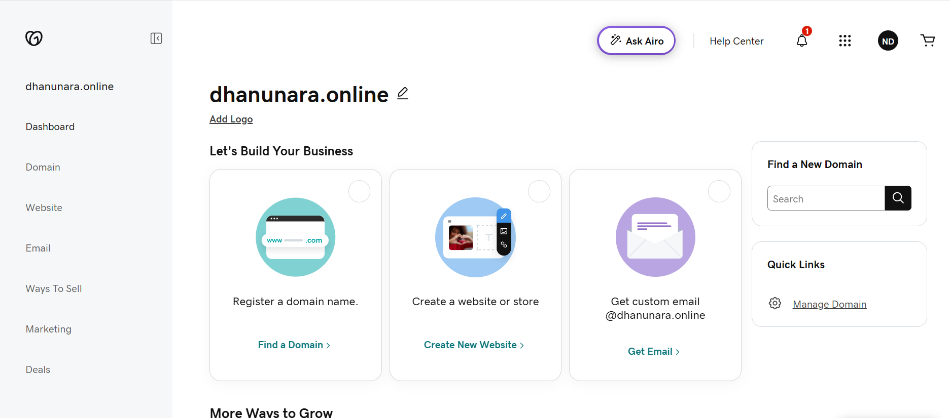

3.Deploy a static website in S3.
TITLE:
S3 static website

PREREQUISITES:
S3 bucket with index.html

STEP-BY-STEP-IMPLIMENTATION:
First create a bucket and go to properties and go to static website hosting.
In local create a file with some content and add that file to bucket.
And make public that file.
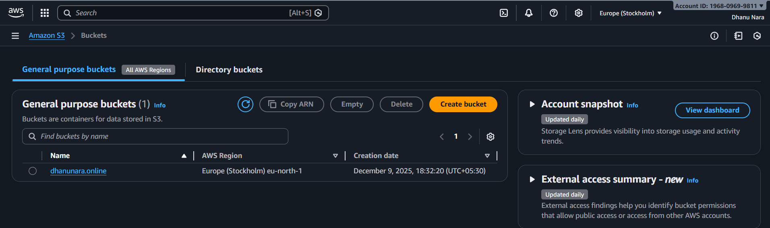

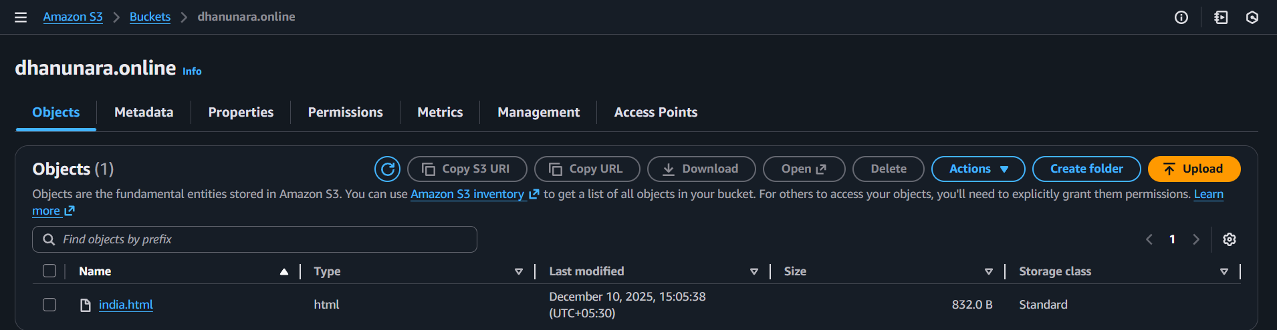
Now check in browser that file with bucket arn.

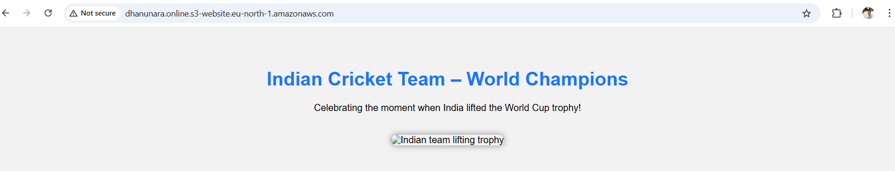
CONCLUSION:
If the bucket ARN is working then it is successful.

4.Create a CDN and attach one SSL certificate.
TITLE:
Attaching CDN one SSL certificate.

PREREQUISITES:
Bucket with updated website
Cloud front distribution
Route 53 hosted zone
Validate SSL (ACM)

STEP-BY-STEP-VALIDATION:

First created a bucket and uploaded a index.html file in the bucket.
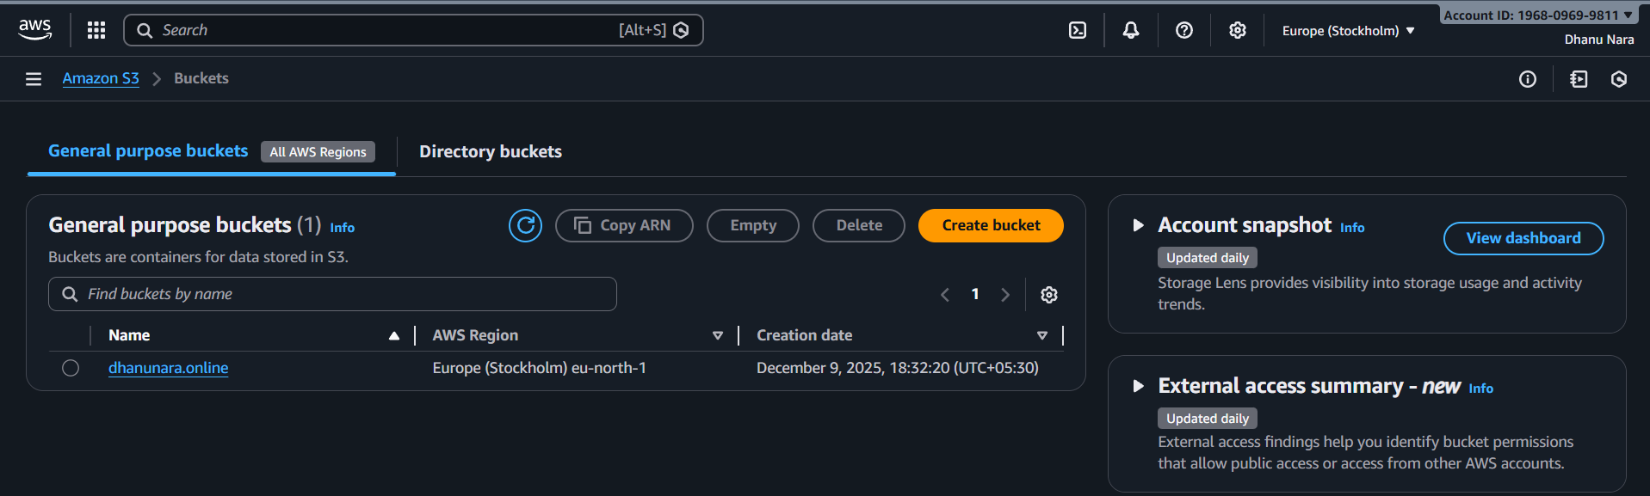
And checked the website in browser with bucket arn
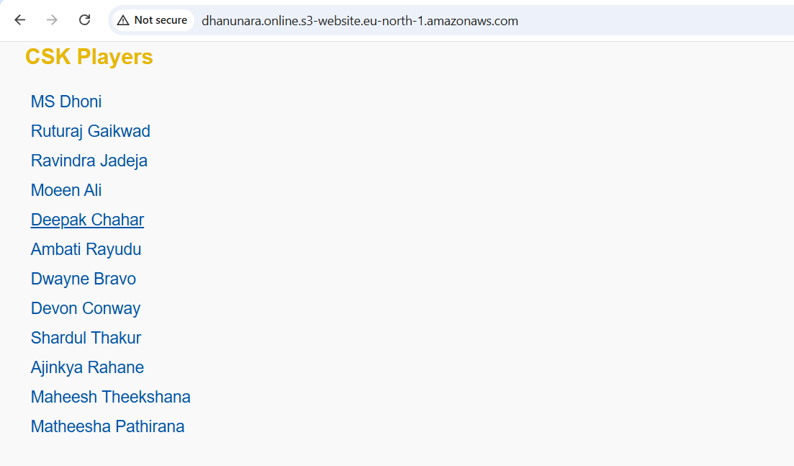
Now created a CloudFront distribution.
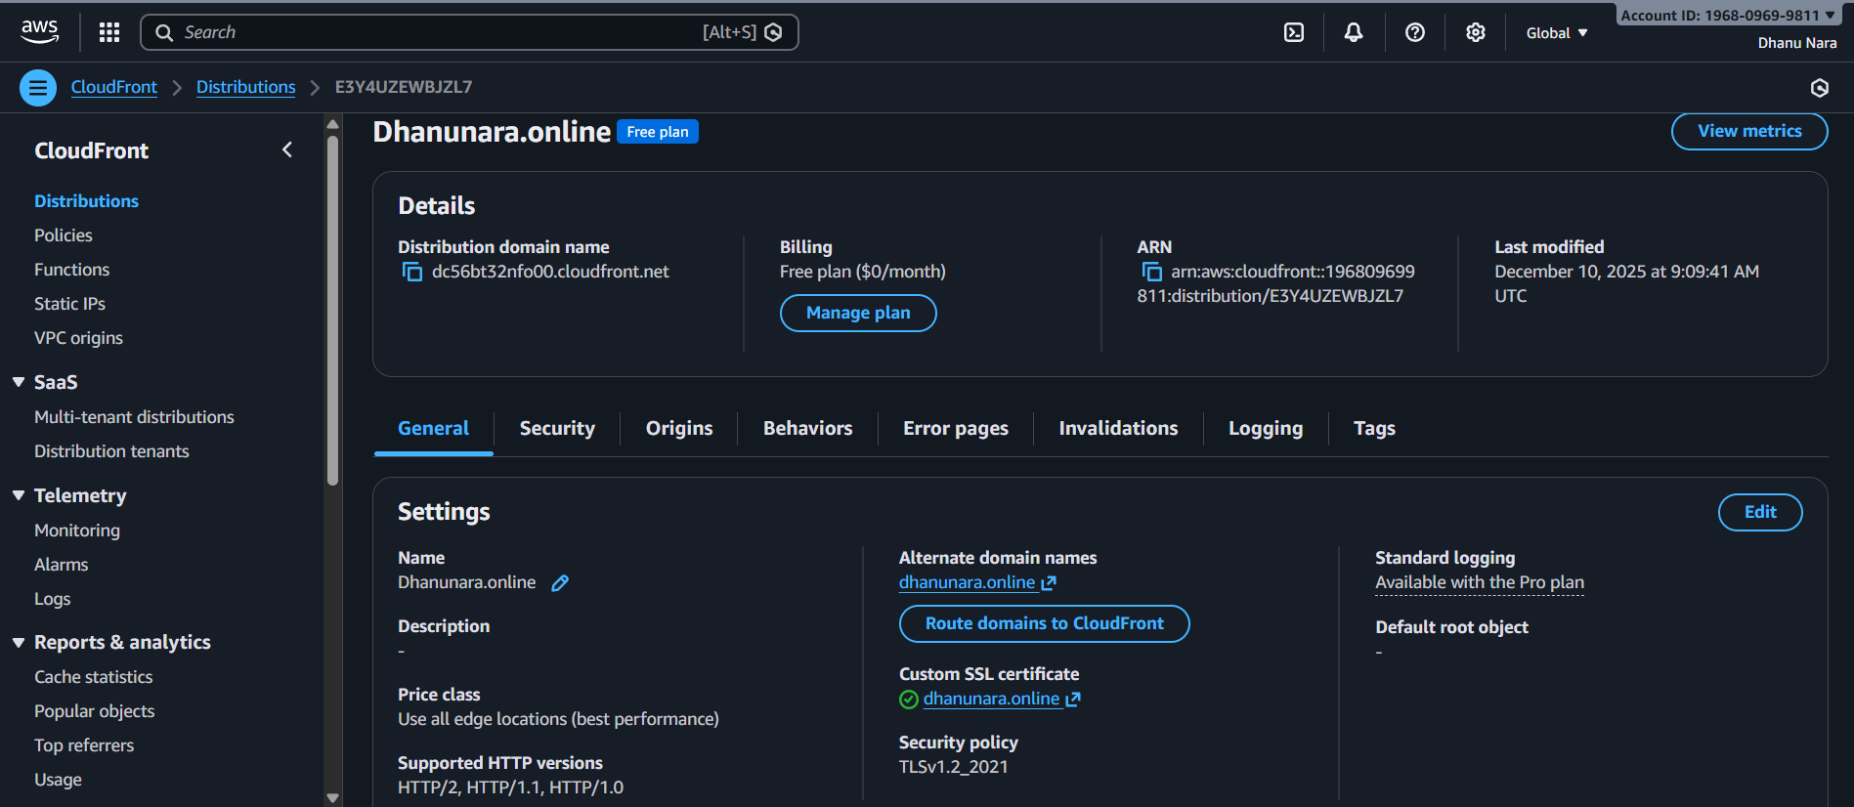
And checked in browser with the CloudFront.

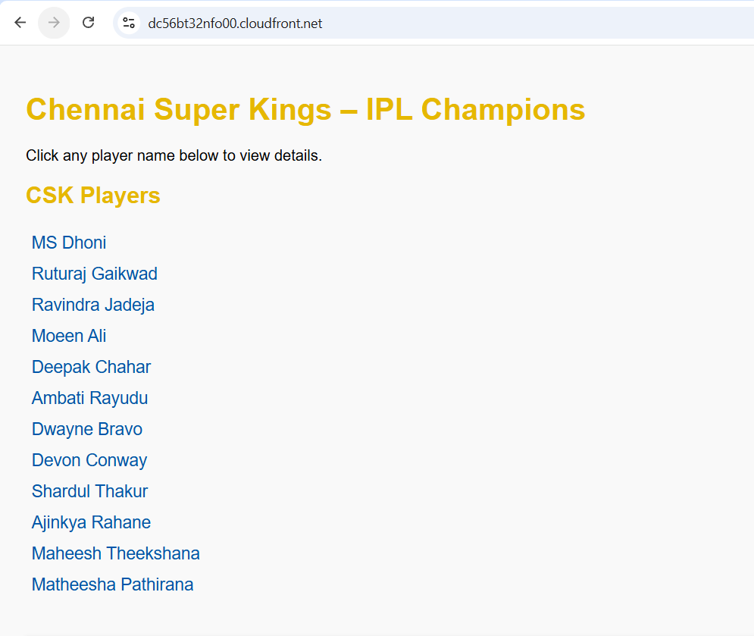
Created a SSL certificate.

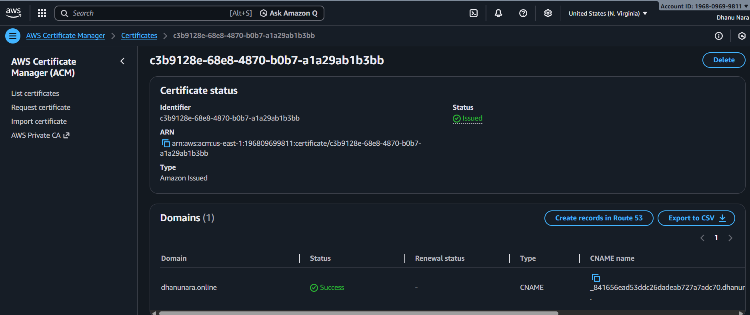
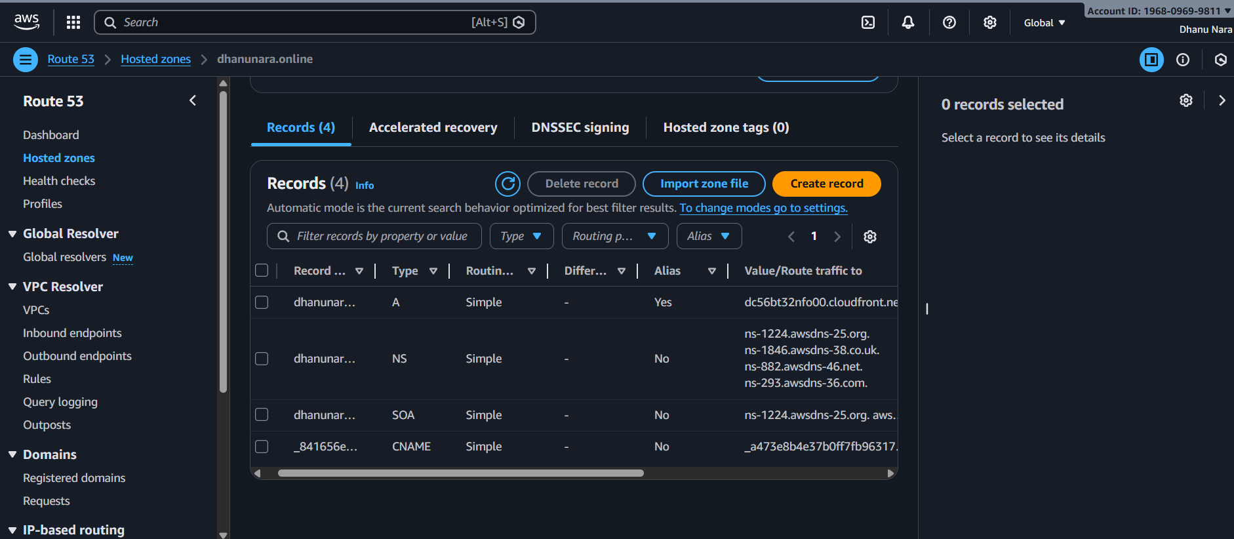
And checked with domain name

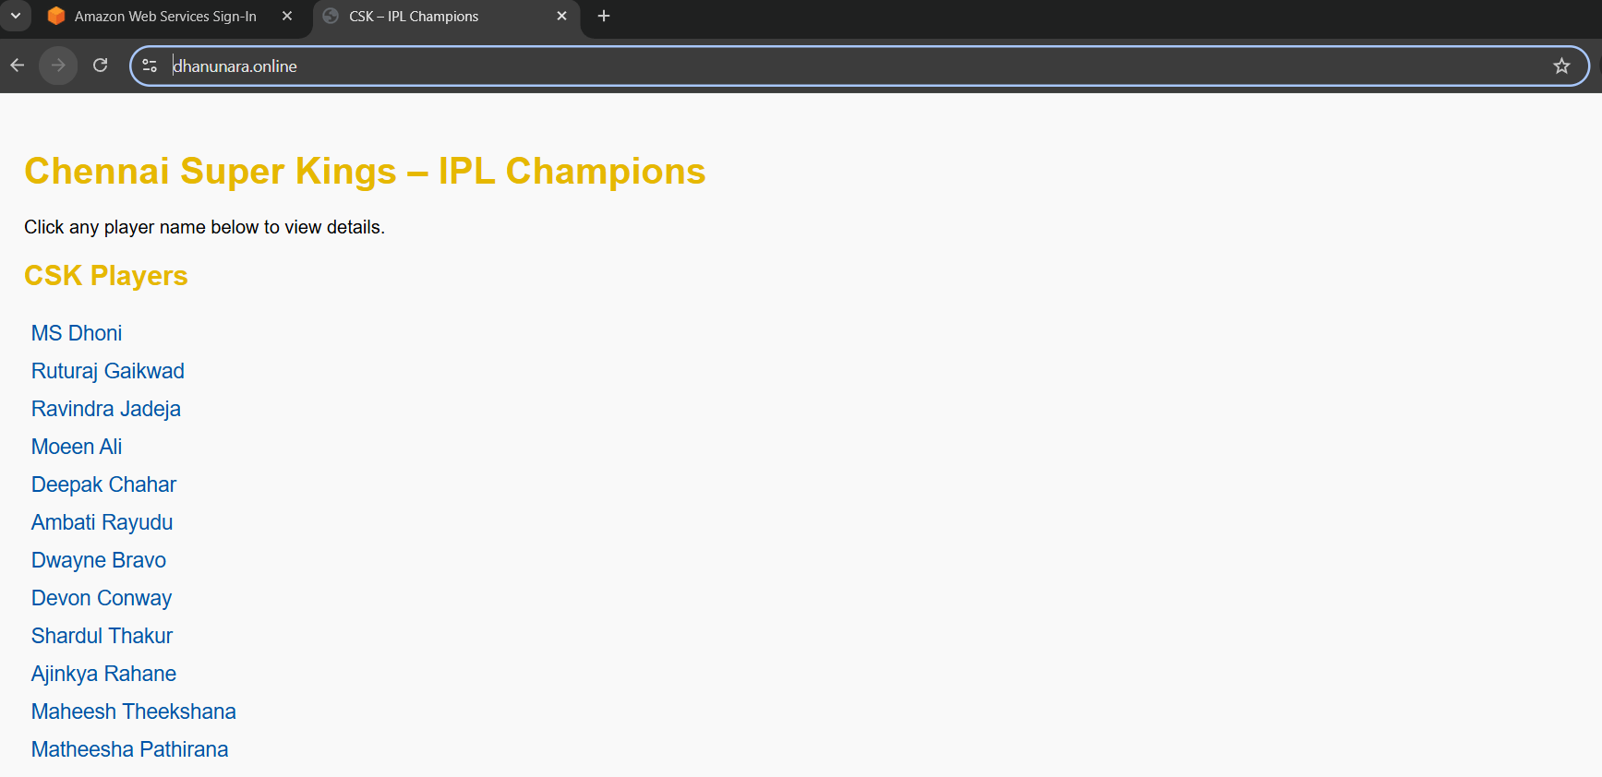
CONCLUSION: To access the website securely.

5.Create a Route 53 hosted zone map the domain with the CDN.

TITLE:
Mapping hosted zone of route 53 with the domain of CDN.

PREREQUISITES:
Create a Route 53 Hosted Zone
Update the name servers in domain registrar
Get the CloudFront domain
Add A record (Alias-CloudFront)
Validate SSL (ACM)

STEP-BY-STEP VALIDATION:
After creating hosted zone we will see NS records + SOA record created automatically.
Now add the name servers to Domain registrar.

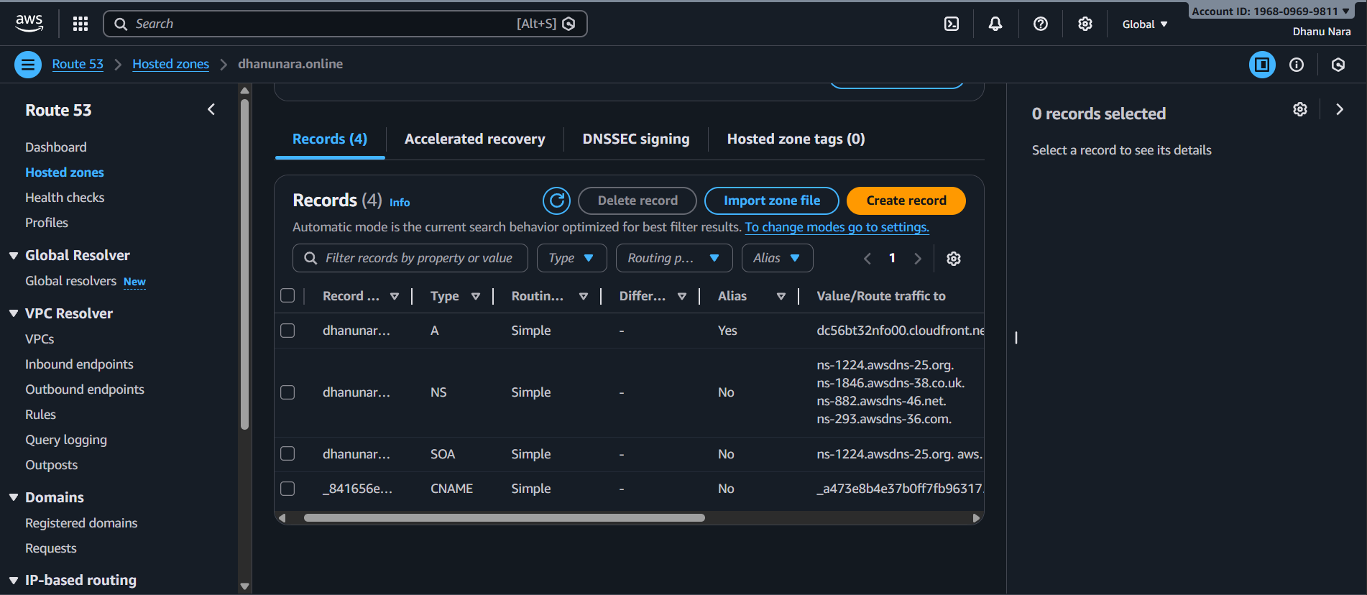

Create SSL certificate and attach that inside CloudFront.
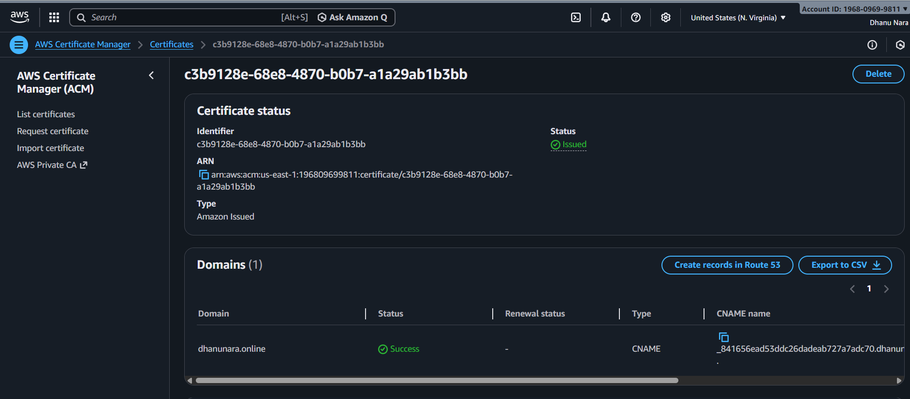
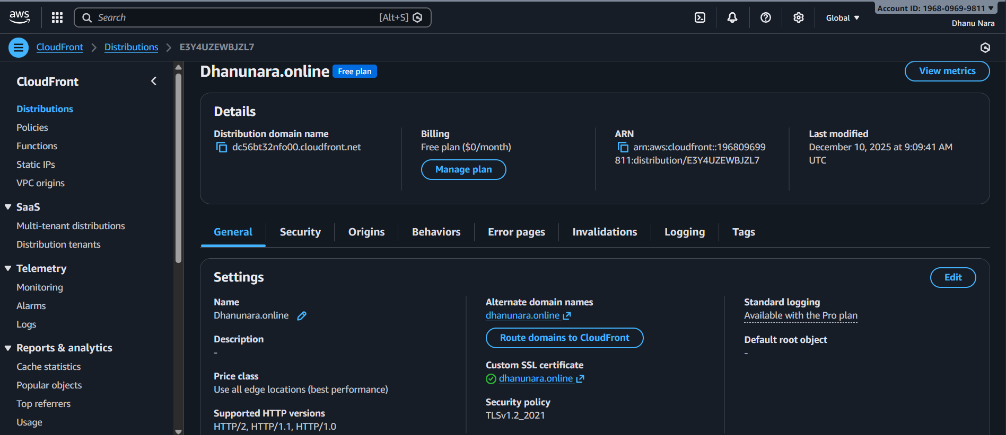
Create a record (Alias – CloudFront ).
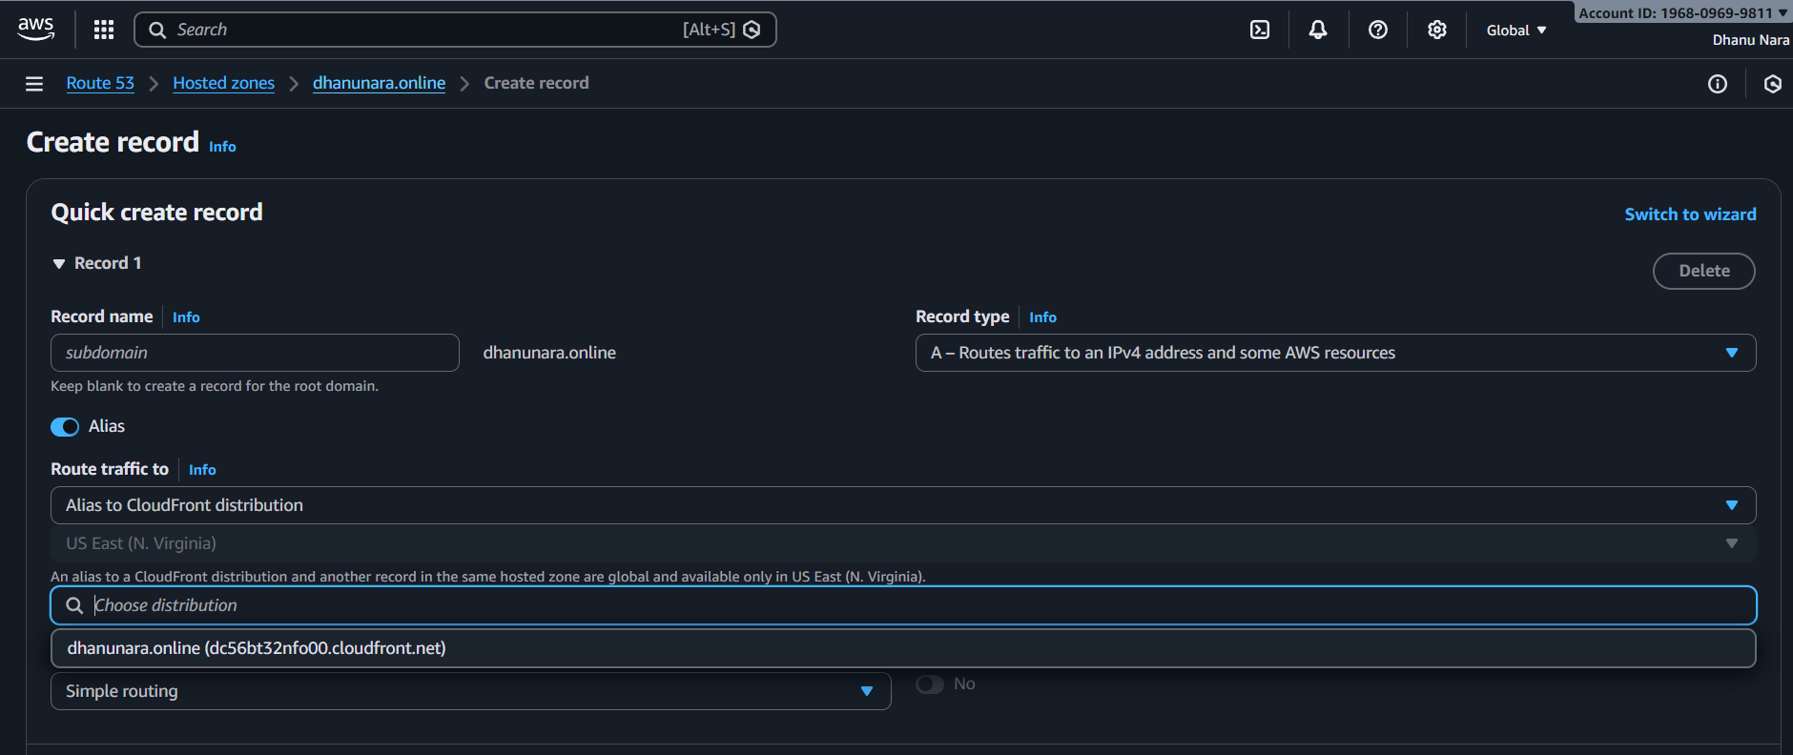
Now enter the domain name in browser.
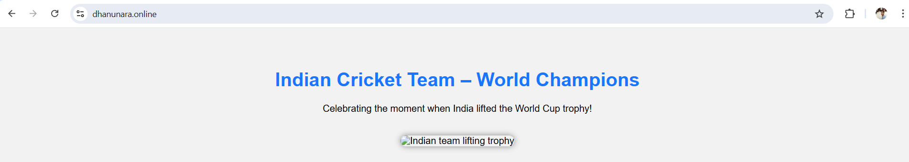

6.Update the index.html in the S3 bucket and ensure the updated file is accessible using the domain name.
TITLE:
To check the updated file directly using domain name.
Objective:
To see directly the updated website with domain name

PREREQUISITES:
Bucket with updated website
Cloud front distribution
Route 53 hosted zone
Validate SSL (ACM)

STEP-BY-STEP-IMPLEMENTATION:
Created a new index.html in S3.
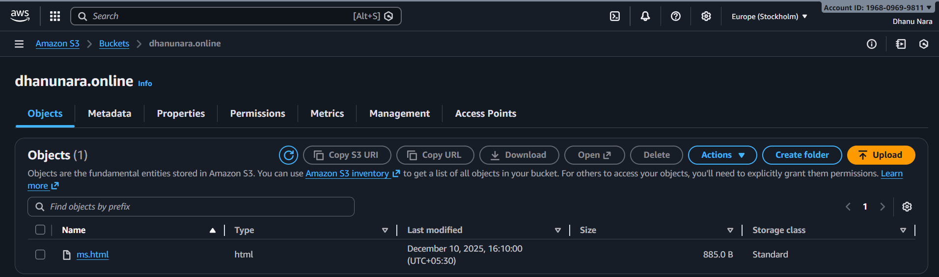
Checked with domain name directly.
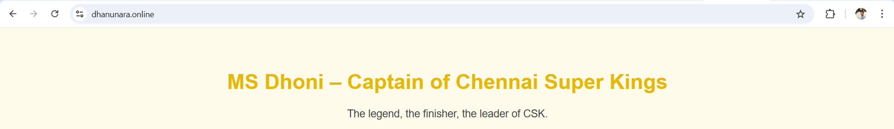
CONCLUSION:
After configuring the CloudFront and validating of SSL certificate and Route 53 Hosted Zone directly we can get the website with domain name itself in {https}.
7.dhanunara.online

